Trace Stewart

CPE301 – SPRING 2018

Design Assignment X

**DO NOT REMOVE THIS PAGE DURING SUBMISSION:**

The student understands that all required components should be submitted in complete for grading of this assignment.

|  |  |  |  |
| --- | --- | --- | --- |
| **NO** | **SUBMISSION ITEM** | **COMPLETED (Y/N)** | **MARKS**  **(/MAX)** |
| 1 | COMPONENTS LIST AND CONNECTION BLOCK DIAGRAM w/ PINS |  |  |
| 2. | INITIAL CODE OF TASK 1/A |  |  |
| 3. | INCREMENTAL / DIFFERENTIAL CODE OF TASK 2/B |  |  |
| 3. | INCREMENTAL / DIFFERENTIAL CODE OF TASK 3/C |  |  |
| 3. | INCREMENTAL / DIFFERENTIAL CODE OF TASK 4/D |  |  |
| 3. | INCREMENTAL / DIFFERENTIAL CODE OF TASK 5/E |  |  |
| 4. | SCHEMATICS |  |  |
| 5. | SCREENSHOTS OF EACH TASK OUTPUT |  |  |
| 5. | SCREENSHOT OF EACH DEMO |  |  |
| 6. | VIDEO LINKS OF EACH DEMO |  |  |
| 7. | GOOGLECODE LINK OF THE DA |  |  |
|  |  |  |  |
|  |  |  |  |

1. **COMPONENTS LIST AND CONNECTION BLOCK DIAGRAM w/ PINS**

None.

1. **INITIAL/DEVELOPED CODE OF TASK 1/A**

RESET:

.equ STARTADDS = 0x0222 ; Starting Address

.equ count = 255 ; Part 1 of the counter to 300

.equ count1 = 46 ; Part 2 of the counter to 300

.org 0

clr r0 ; Clearing r0 register

ldi XL, low(STARTADDS) ; XL = STARTADDS[7:0]

ldi XH, high(STARTADDS) ; XH = STARTADDS[15:8]

ldi YL, low(0x400) ; YL = 0x00

ldi YH, high(0x400) ; YH = 0x04

ldi ZL, low(0x600) ; ZL = 0x00

ldi ZH, high(0x600) ; ZH = 0x06

; Initializing count registers

ldi r21, count ; r21 = 255

ldi r22, count1 ; r22 = 46

ldi r20, 5 ; r20 = 5

; Clearing Registers for sums

clr r0 ; R0 = 0

clr r16 ; R16 = 0

clr r17 ; R17 = 0

clr r18 ; R18 = 0

clr r19 ; R19 = 0

clr r5 ; r5 = 0

inc r5 ; r5 = 1

START:

; Adding lower and upper address bits to be stored

mov r1, XL ; R1 = XL

add r1, XH ; R1 = XL + XH

mov r3, r1 ; R3 = R1

st X+, r3 ; [X] = XL + XH

DONE:

cp r21, r0 ; if(count == 0)

breq NOTYET ; go to NOTYET

sub r21, r5 ; R21 = R21 = R5

brne START ; if(R21 != 0) go to START

NOTYET:

sub r22, r5 ; R22 = R22 - R5

brne Start ; if(R22 != 0) go to START

FIN:

rjmp RESET ; Reset

**MODIFIED CODE OF TASK 2/A from TASK 1/A**

; Checking if divisible by 5

DIVBYFIVE:

cp r1, r20 ; if(R1 < 5)

brlo DIVBAD ; go to DIVBAD

sub r1, r20 ; R1 = R1 - R20

cp r1, r0 ; if(R1 == 0)

breq DIVGOOD ;go to DIVGOOD

rjmp DIVBYFIVE ; go to DIVBYFIVE

DIVGOOD:

st Z+, r3 ; [Z] = XL + XH

add r16, r3 ; R16 = R16 + R3 (lower)

adc r17, r0 ; R17 = R17 + R0 + C (upper)

rjmp DONE ; go to DONE

DIVBAD:

st Y+, r3 ; [Y] = XL + XH

add r18, r3 ; R18 = R18 + R3 (lower)

adc r19, r0 ; R19 = R19 + R0 + C (upper)

rjmp DONE ; goto DONE

DONE:

cp r21, r0 ; if(count == 0)

breq NOTYET ; go to NOTYET

sub r21, r5 ; R21 = R21 = R5

brne START ; if(R21 != 0) go to START

NOTYET:

sub r22, r5 ; R22 = R22 - R5

brne Start ; if(R22 != 0) go to START

FIN:

rjmp RESET ; Reset

1. **SCHEMATICS**

None

1. **SCREENSHOTS OF EACH TASK OUTPUT (ATMEL STUDIO OUTPUT)**

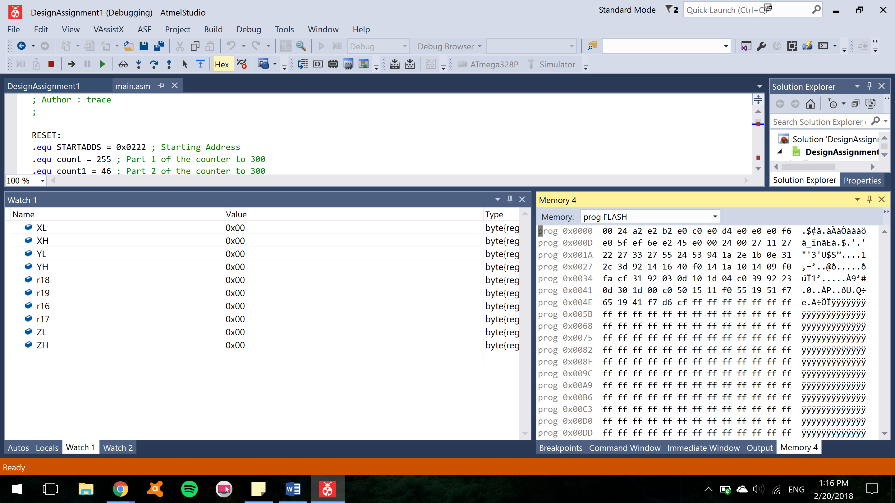

Figure 1 Values of registers before program is started

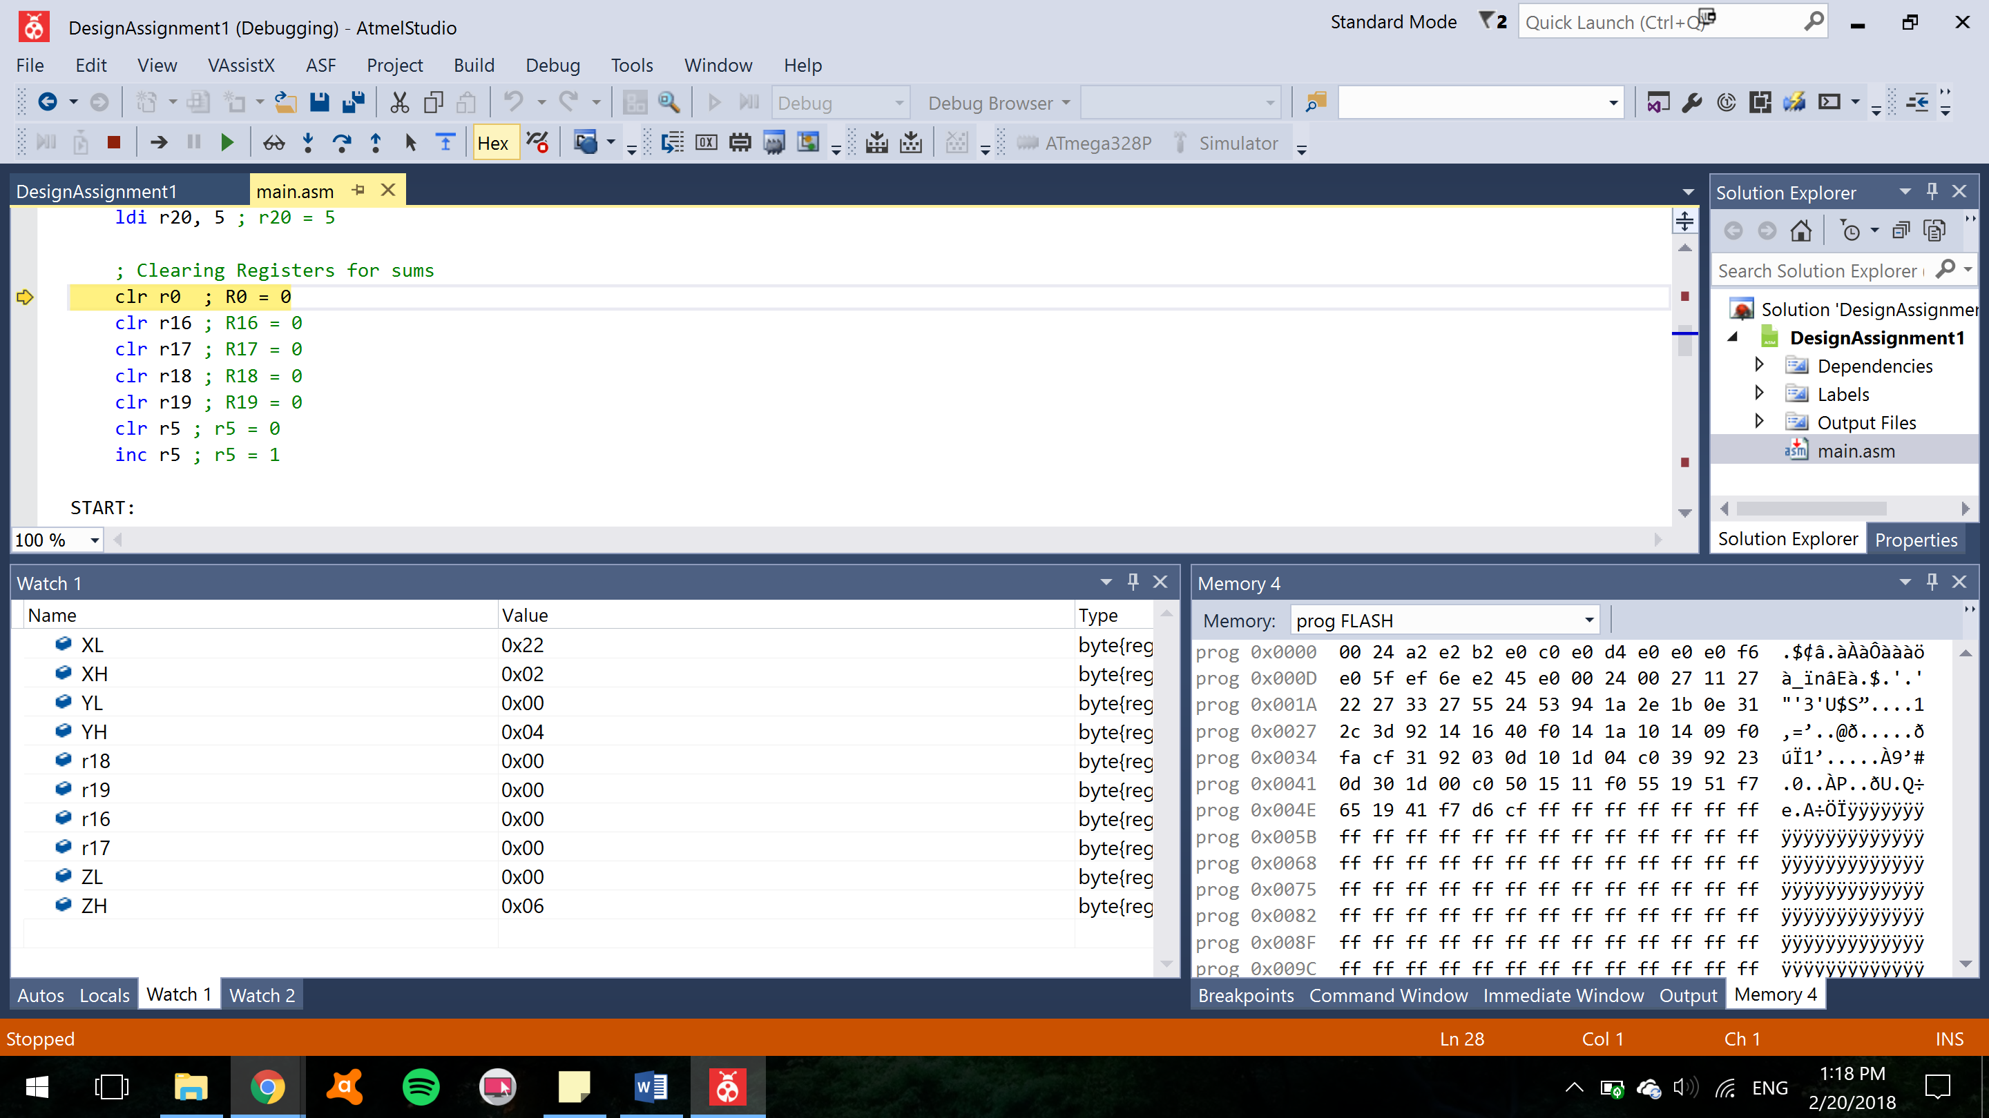

Figure 2 Values of registers after addresses for pointers are stored in X,Y, and Z registers

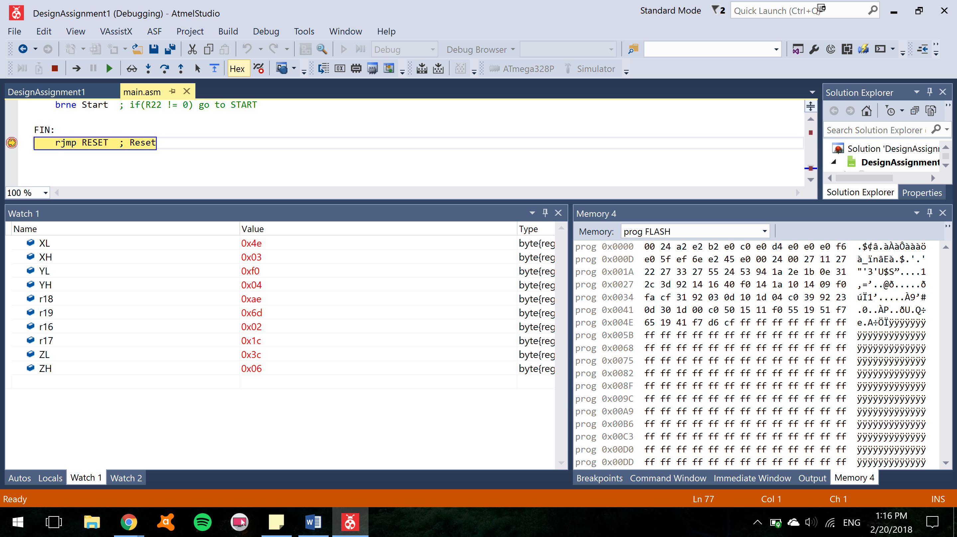

Figure 3 Registers after the program has ran completely through. These are displayed in Hex values.

R16:R17 = **0x1C02** (Hex) = 7170 (Decimal)

R18:R19 = **0x6DAE** (Hex) = 28078 (Decimal)

X (Before) = 0x0222 (Hex) = 546 (Decimal)

X (After) = 0x034E (Hex) = 846 (Decimal)

Y (Before) = 0x0400 (Hex) = 1024 (Decimal)

Y (After) = 0x04F0 (Hex) = 1264 (Decimal)

Z (Before) = 0x0600 (Hex) = 1536 (Decimal)

Z (After) = 0x063C (Hex) = 1596 (Decimal)

Since there is an overflow at location 0x02FE and 0x02FF, instead of getting the values of 257 and 258 added to the sums, 0 and 1 are added. Since there was a note in the homework to not worry about overflow, this is to be left as is.

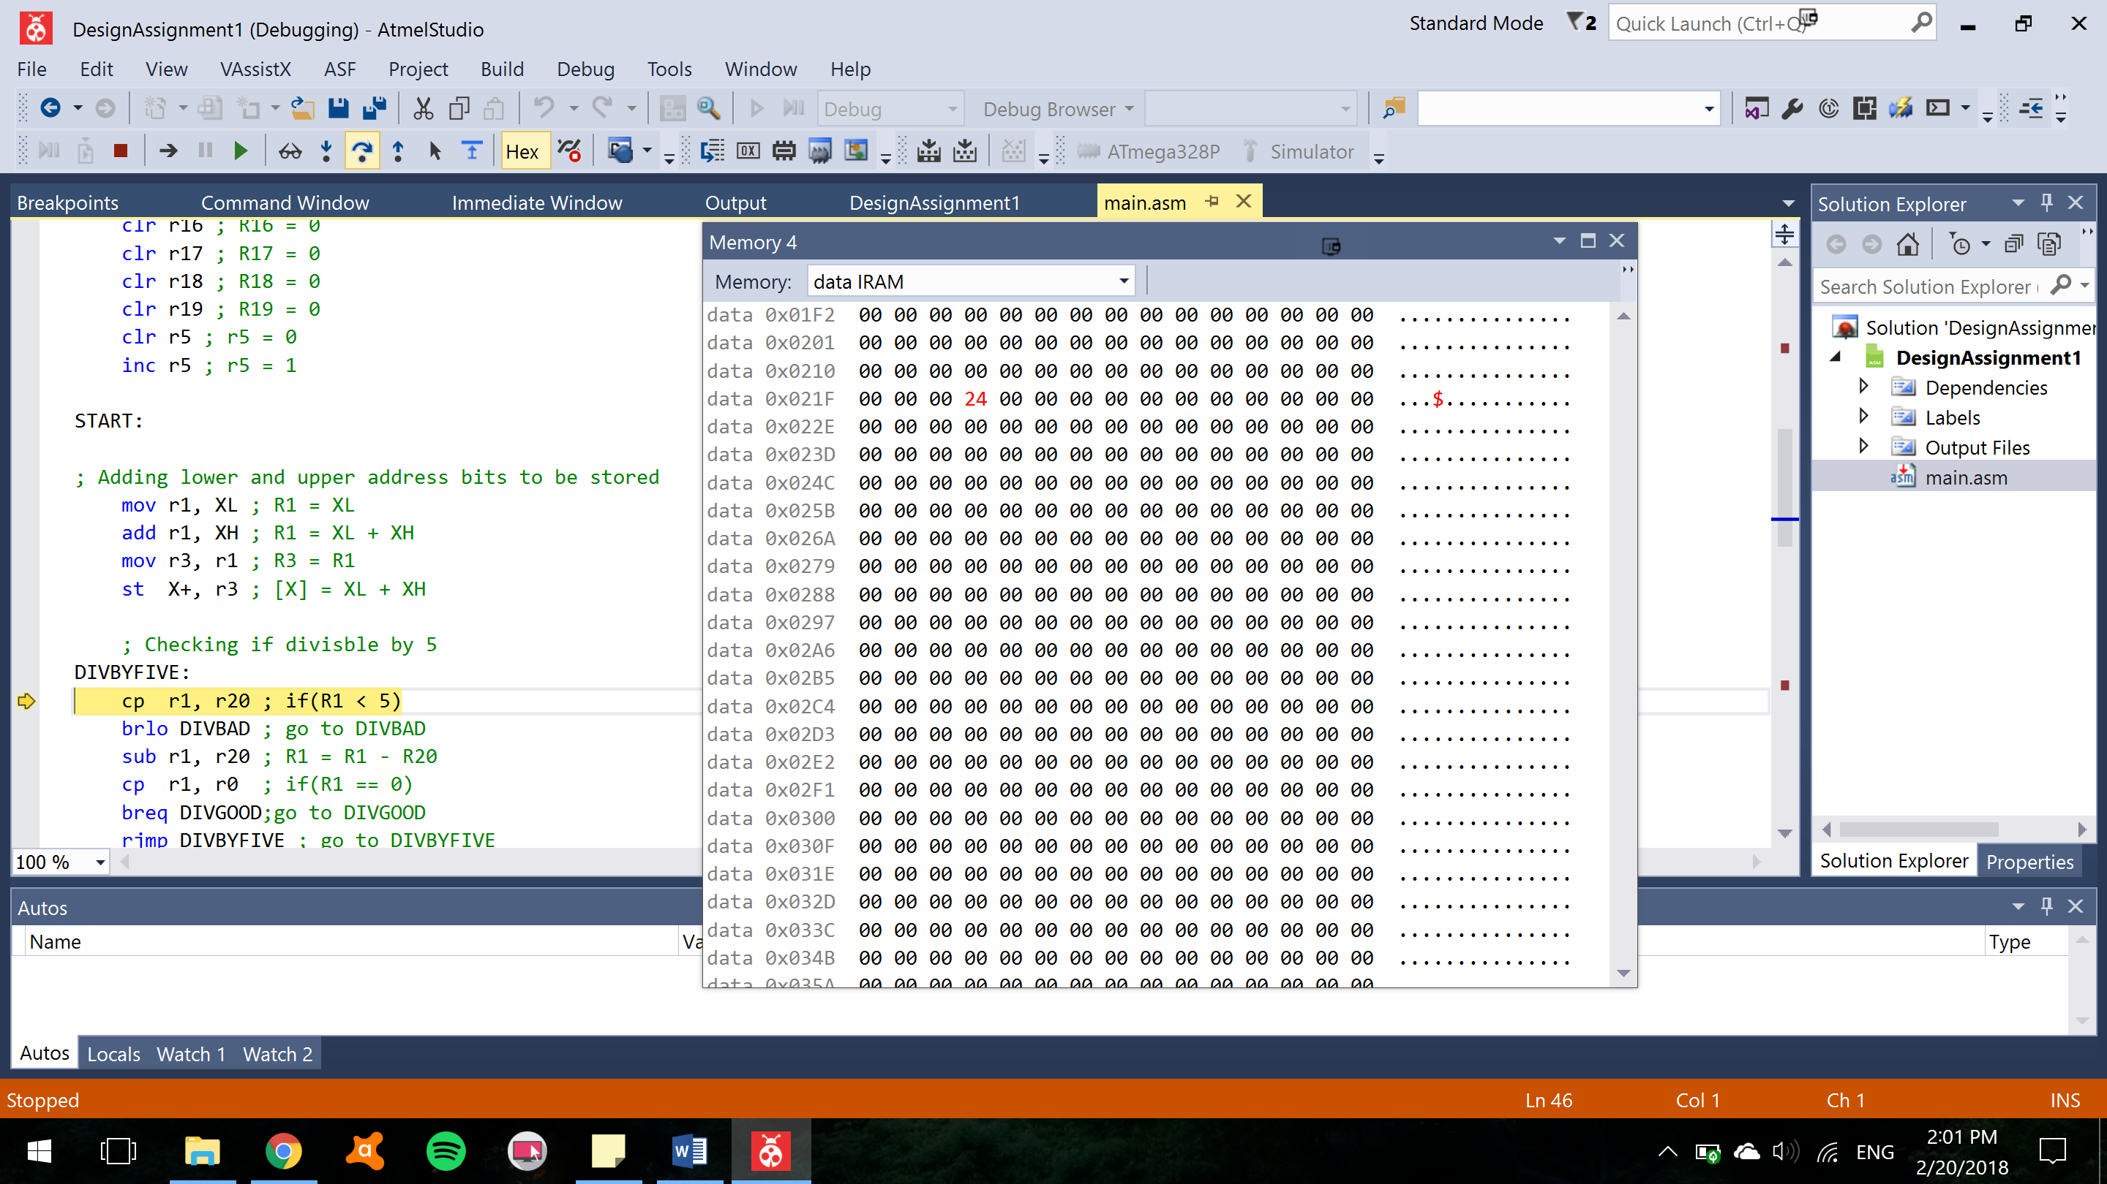

Figure 4 Before storing values into any of the addresses

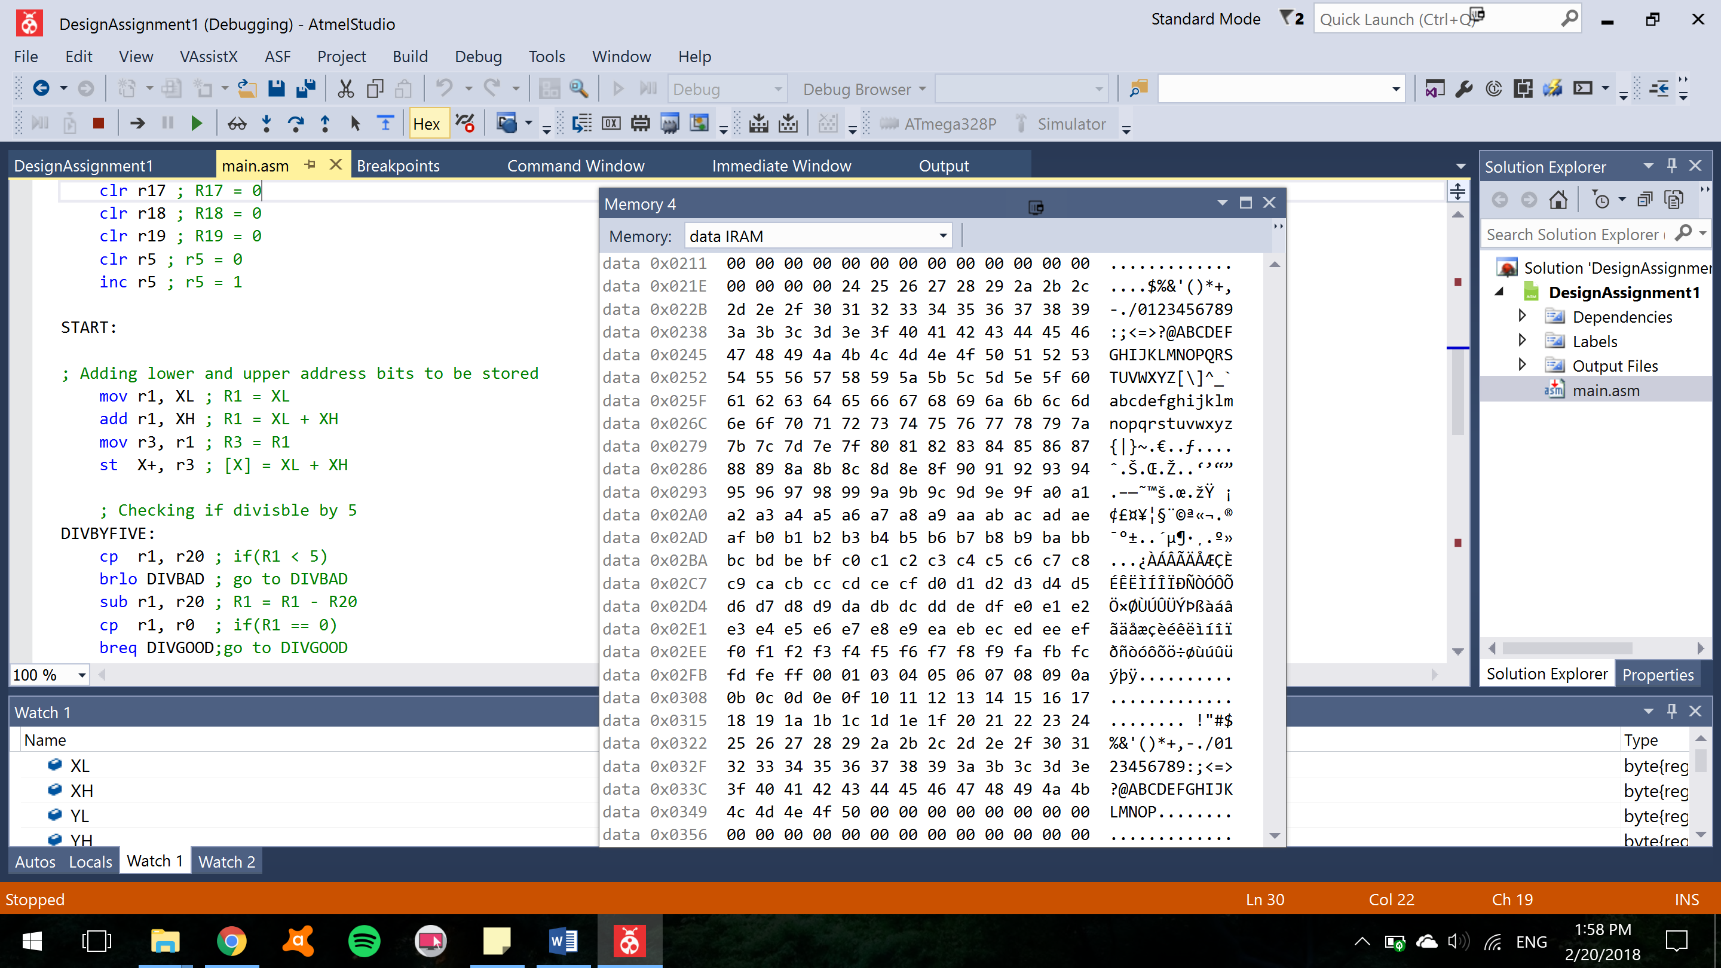

Figure 5 After storing values from location 0x0222

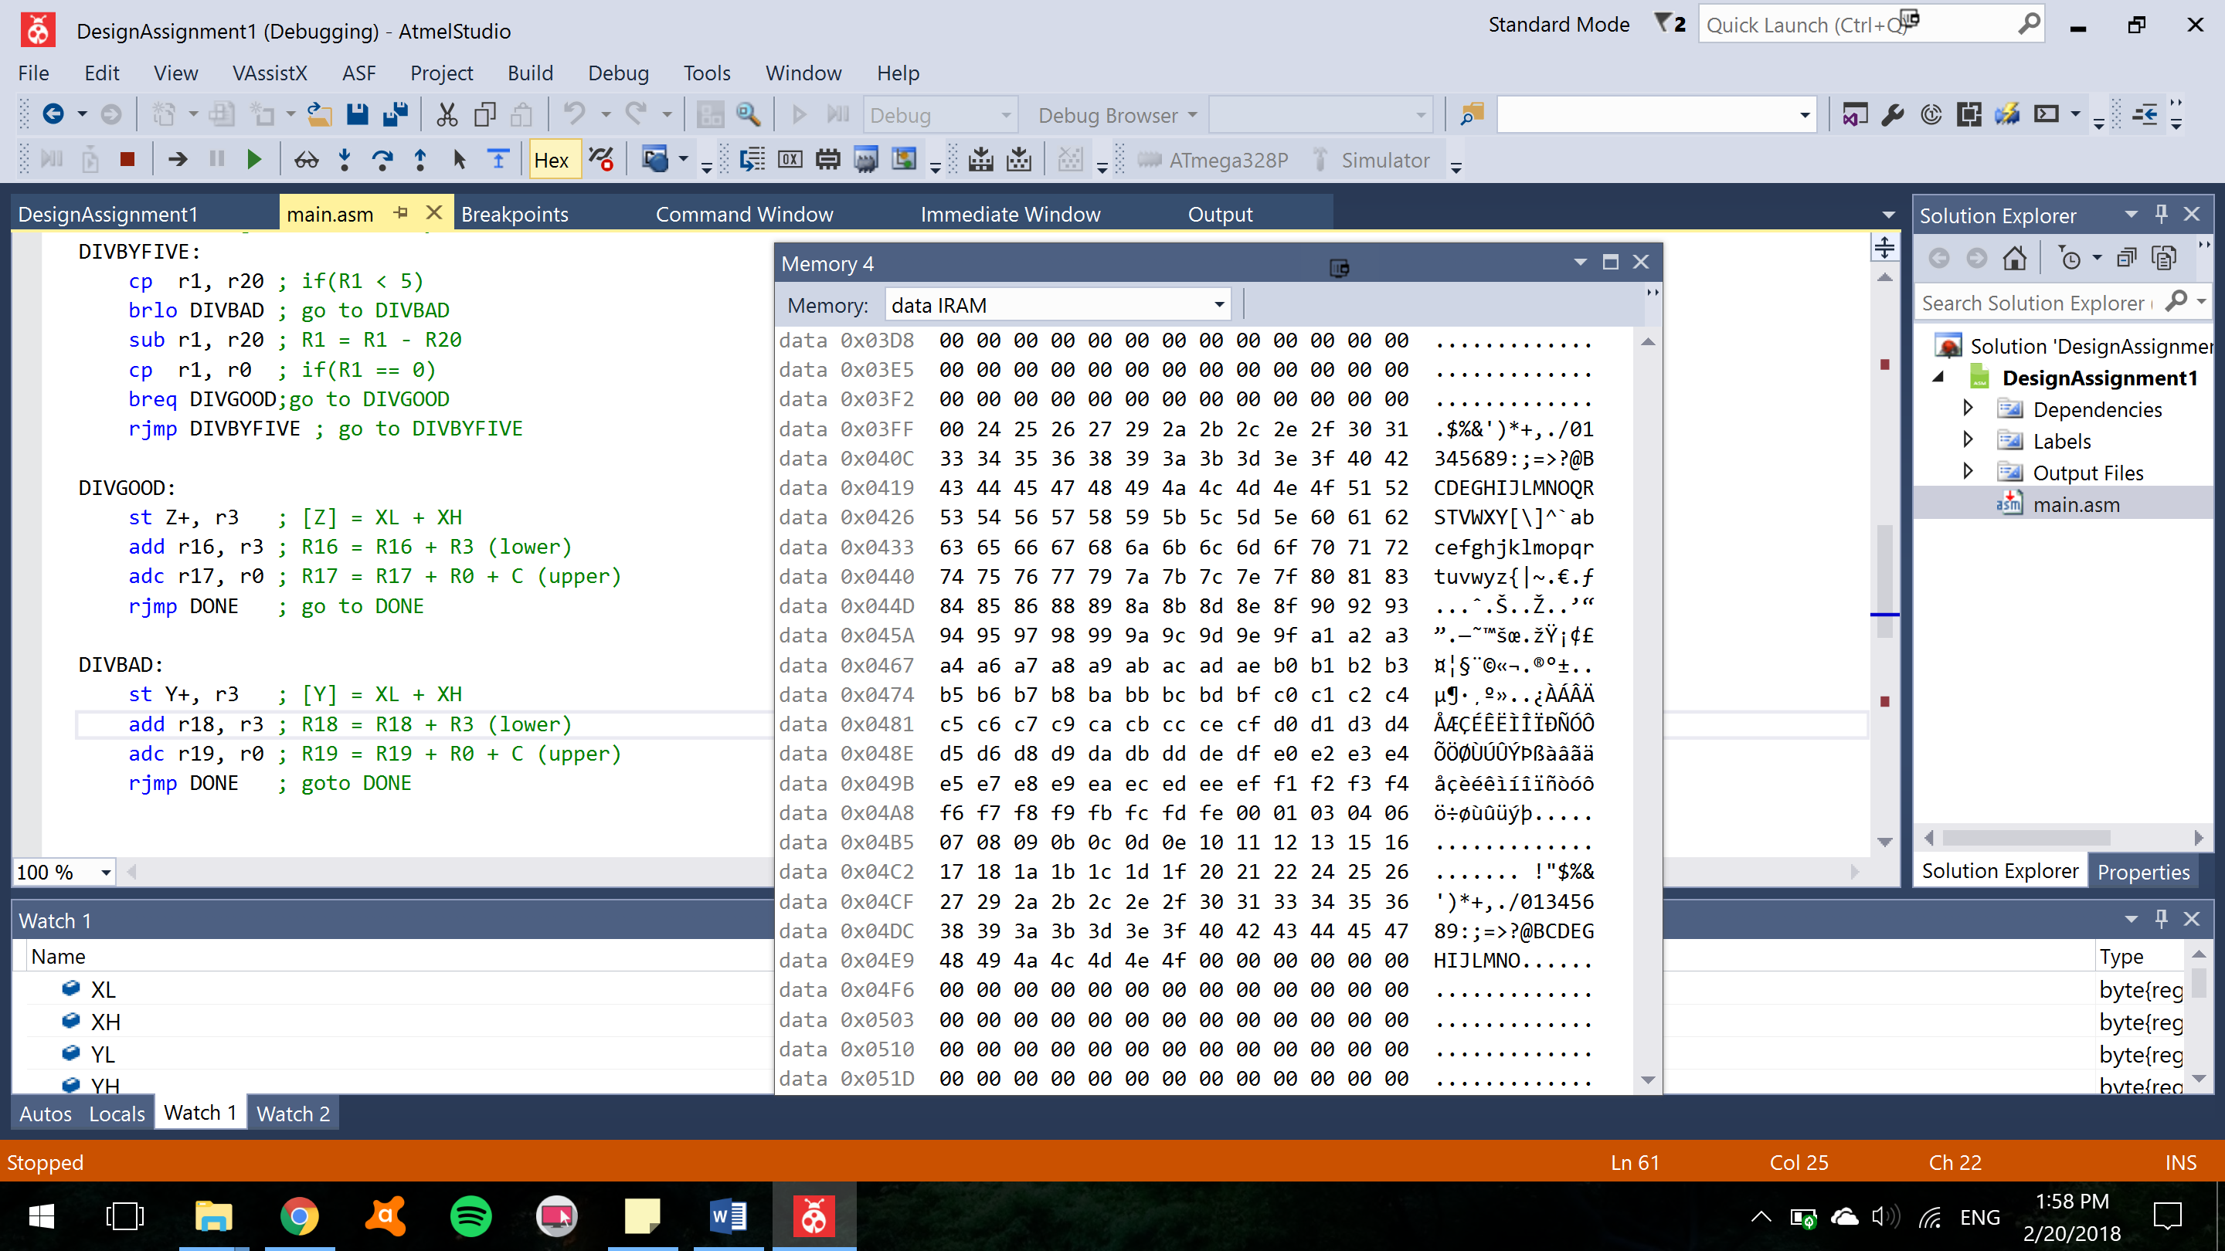

Figure 6 After storing values from location 0x0400

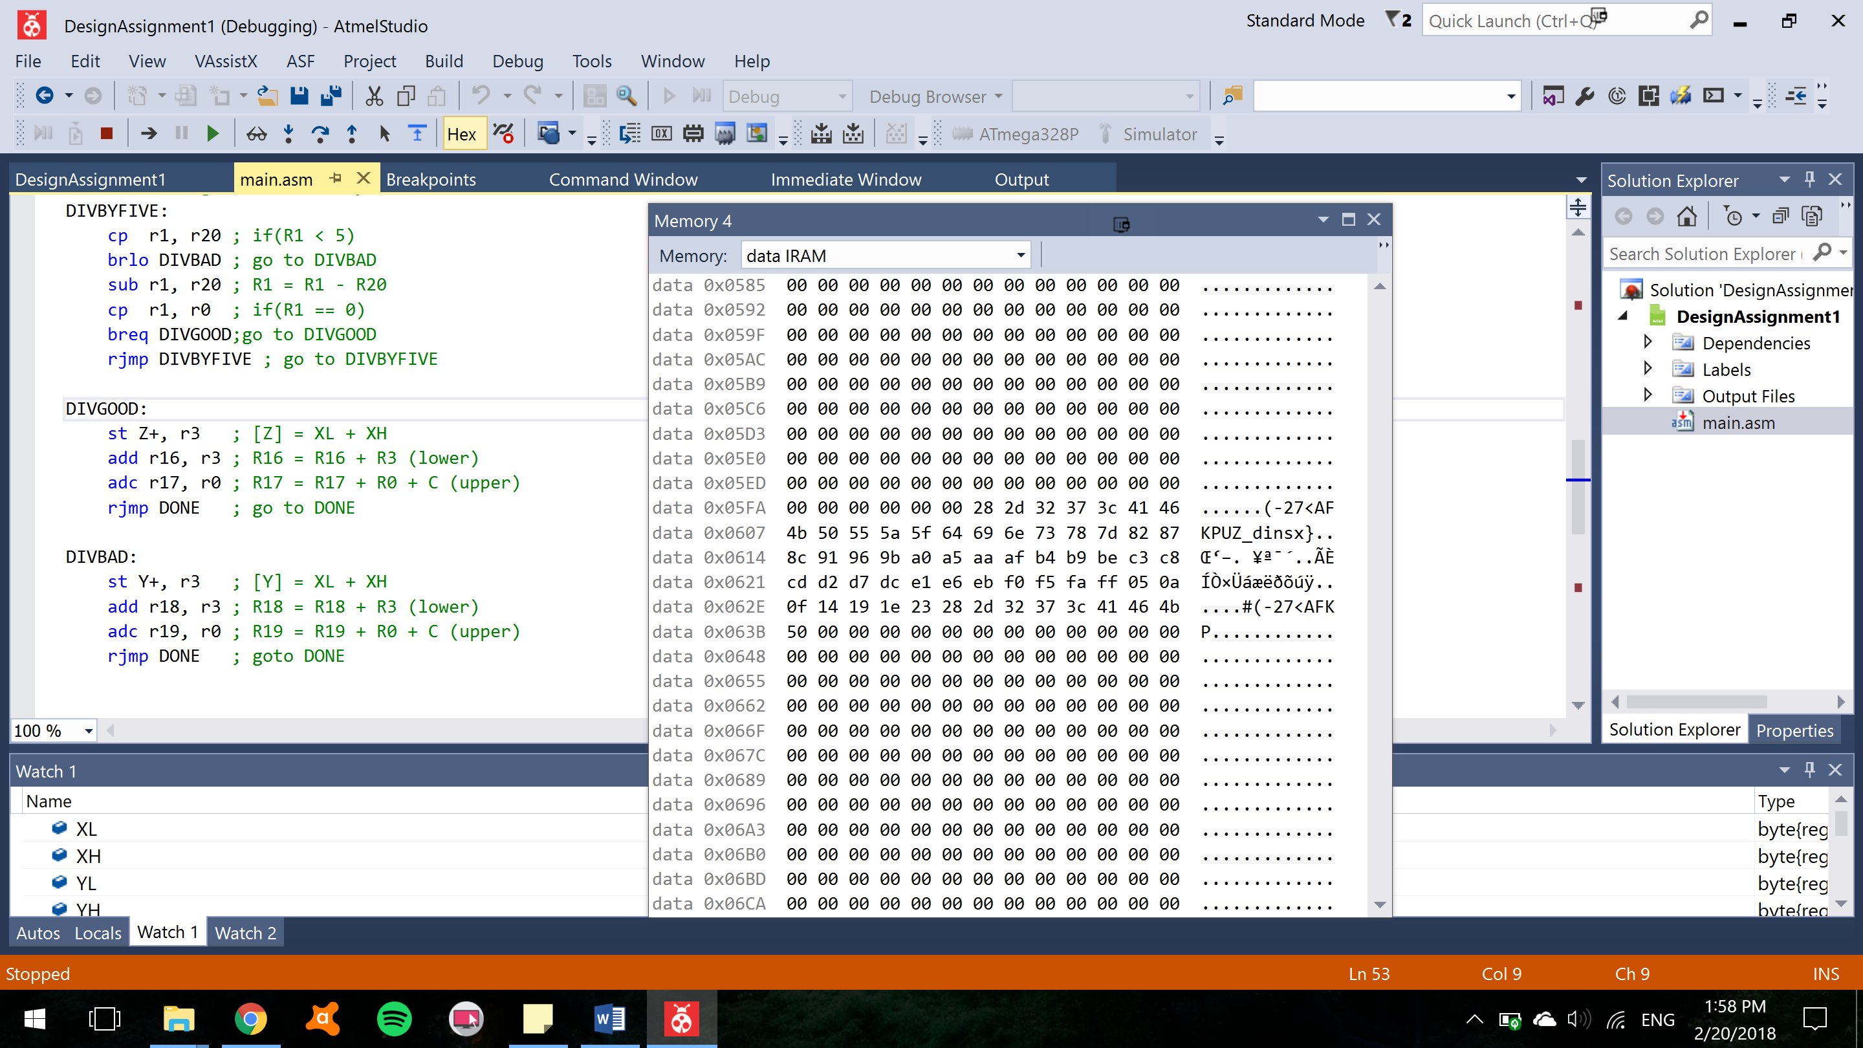

Figure 7 After storing values from location 0x0600

TASK 1

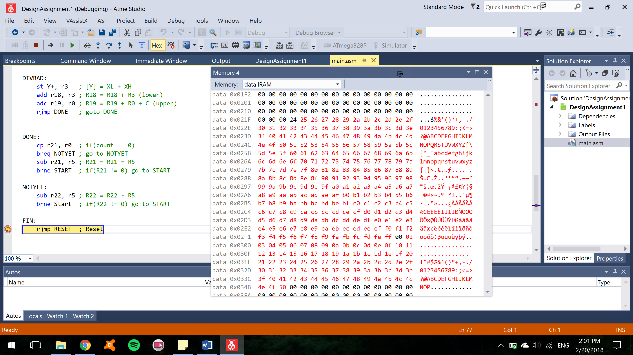

Figure 8 Task one after storing values into addresses starting at 0x0222

TASK 2

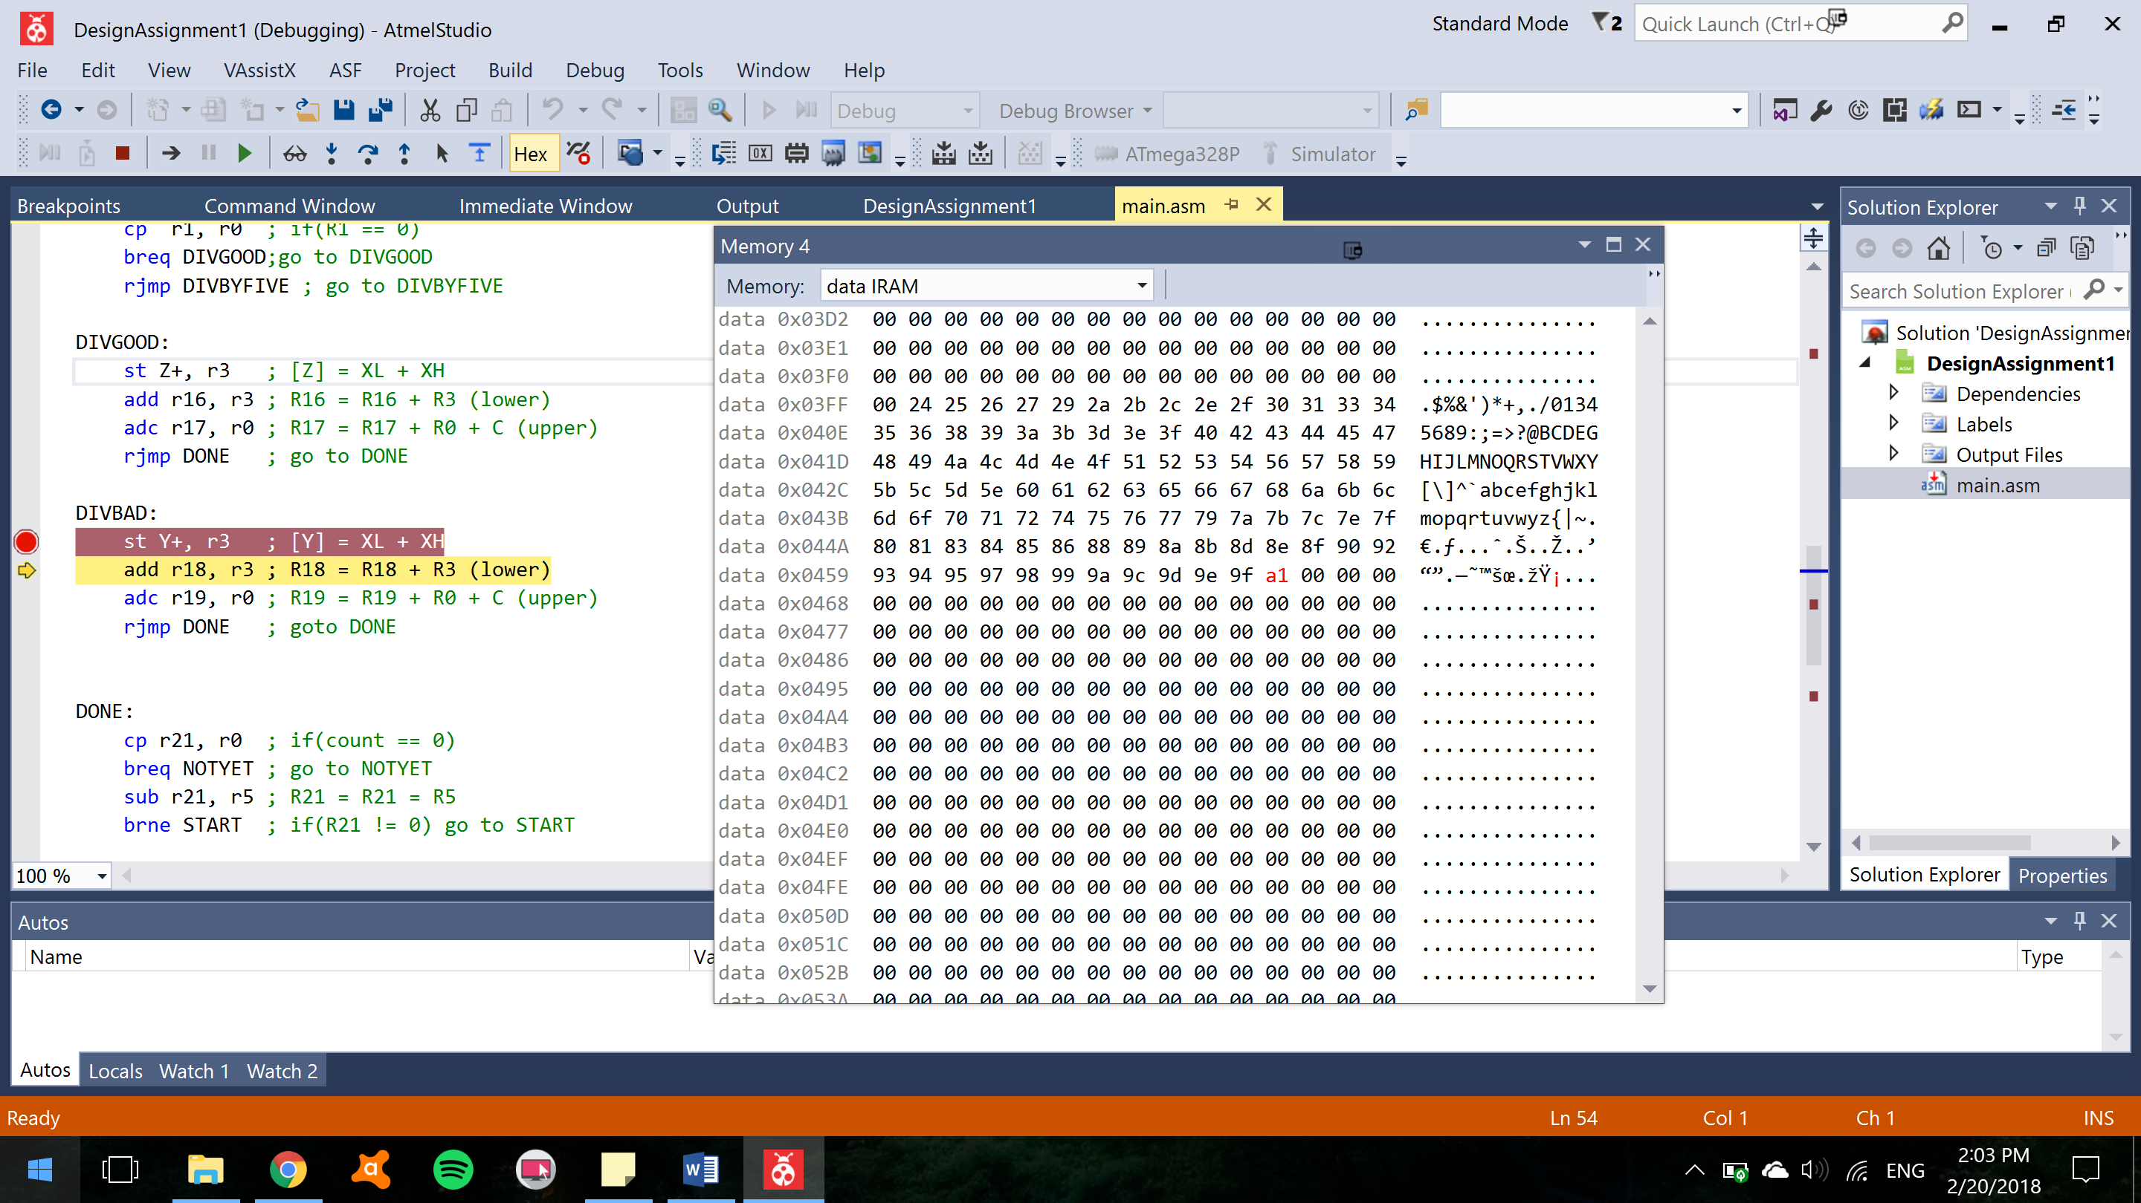

Figure 9 Showing Y pointer while storing numbers

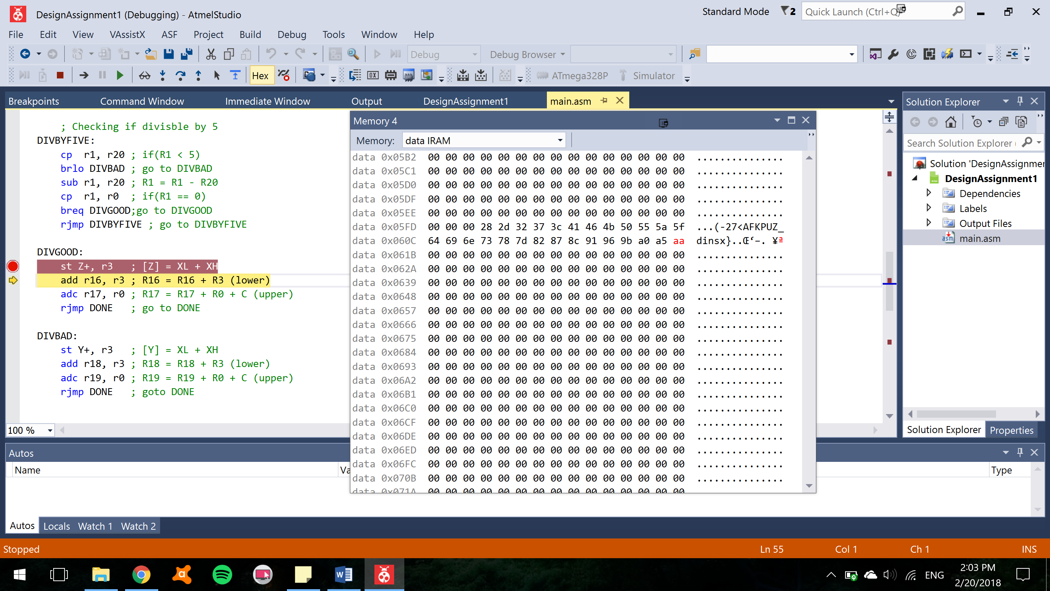

Figure 10 Showing Z pointer while storing numbers

**Task 3**

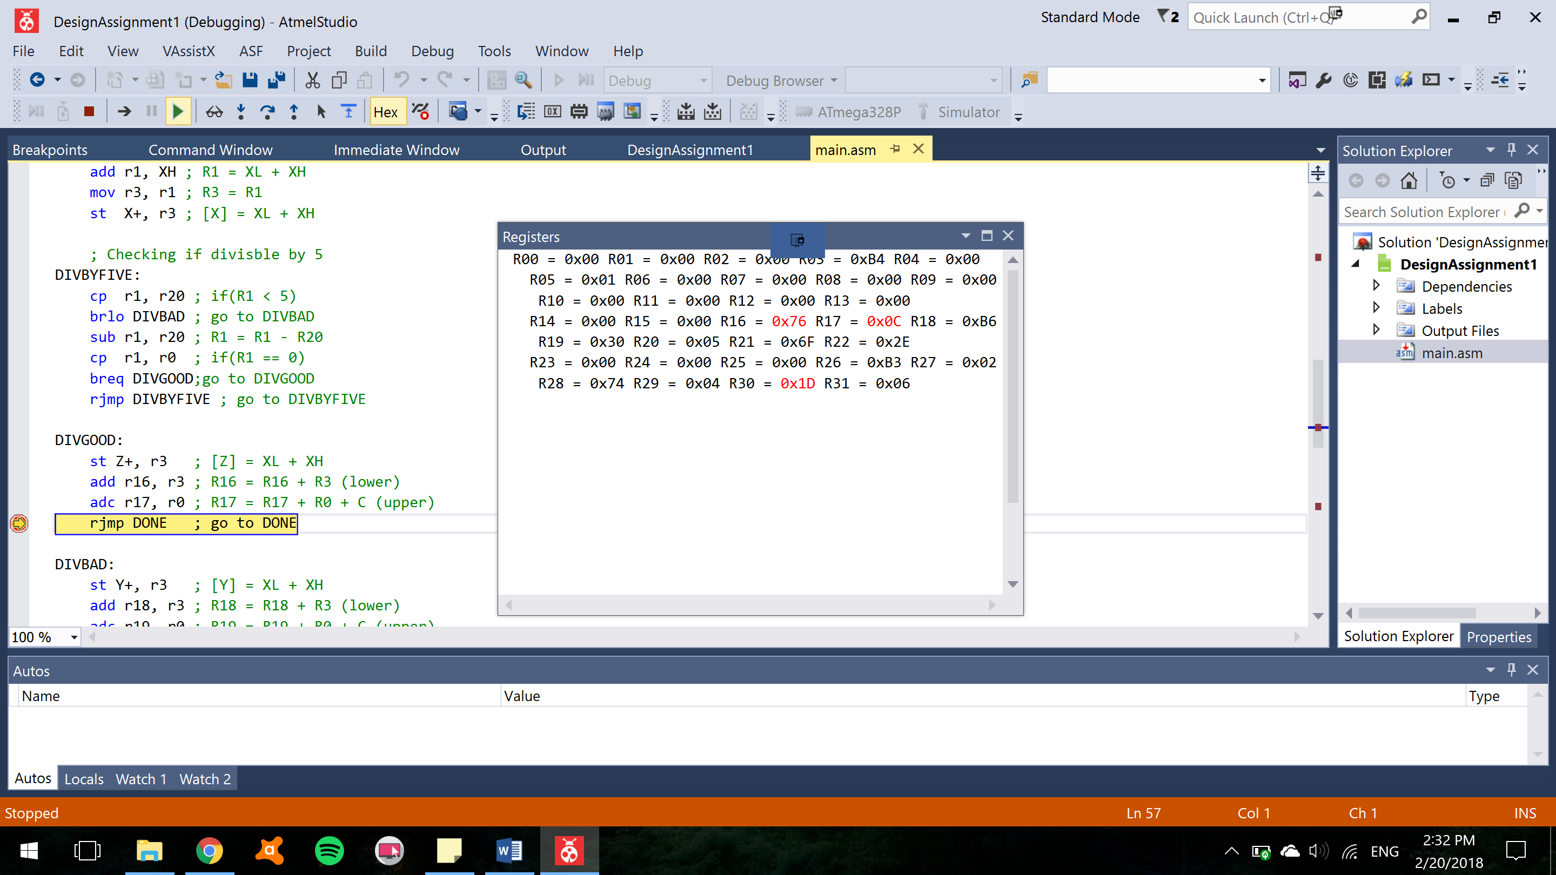

Figure 11 R16:R17 after being added and stored

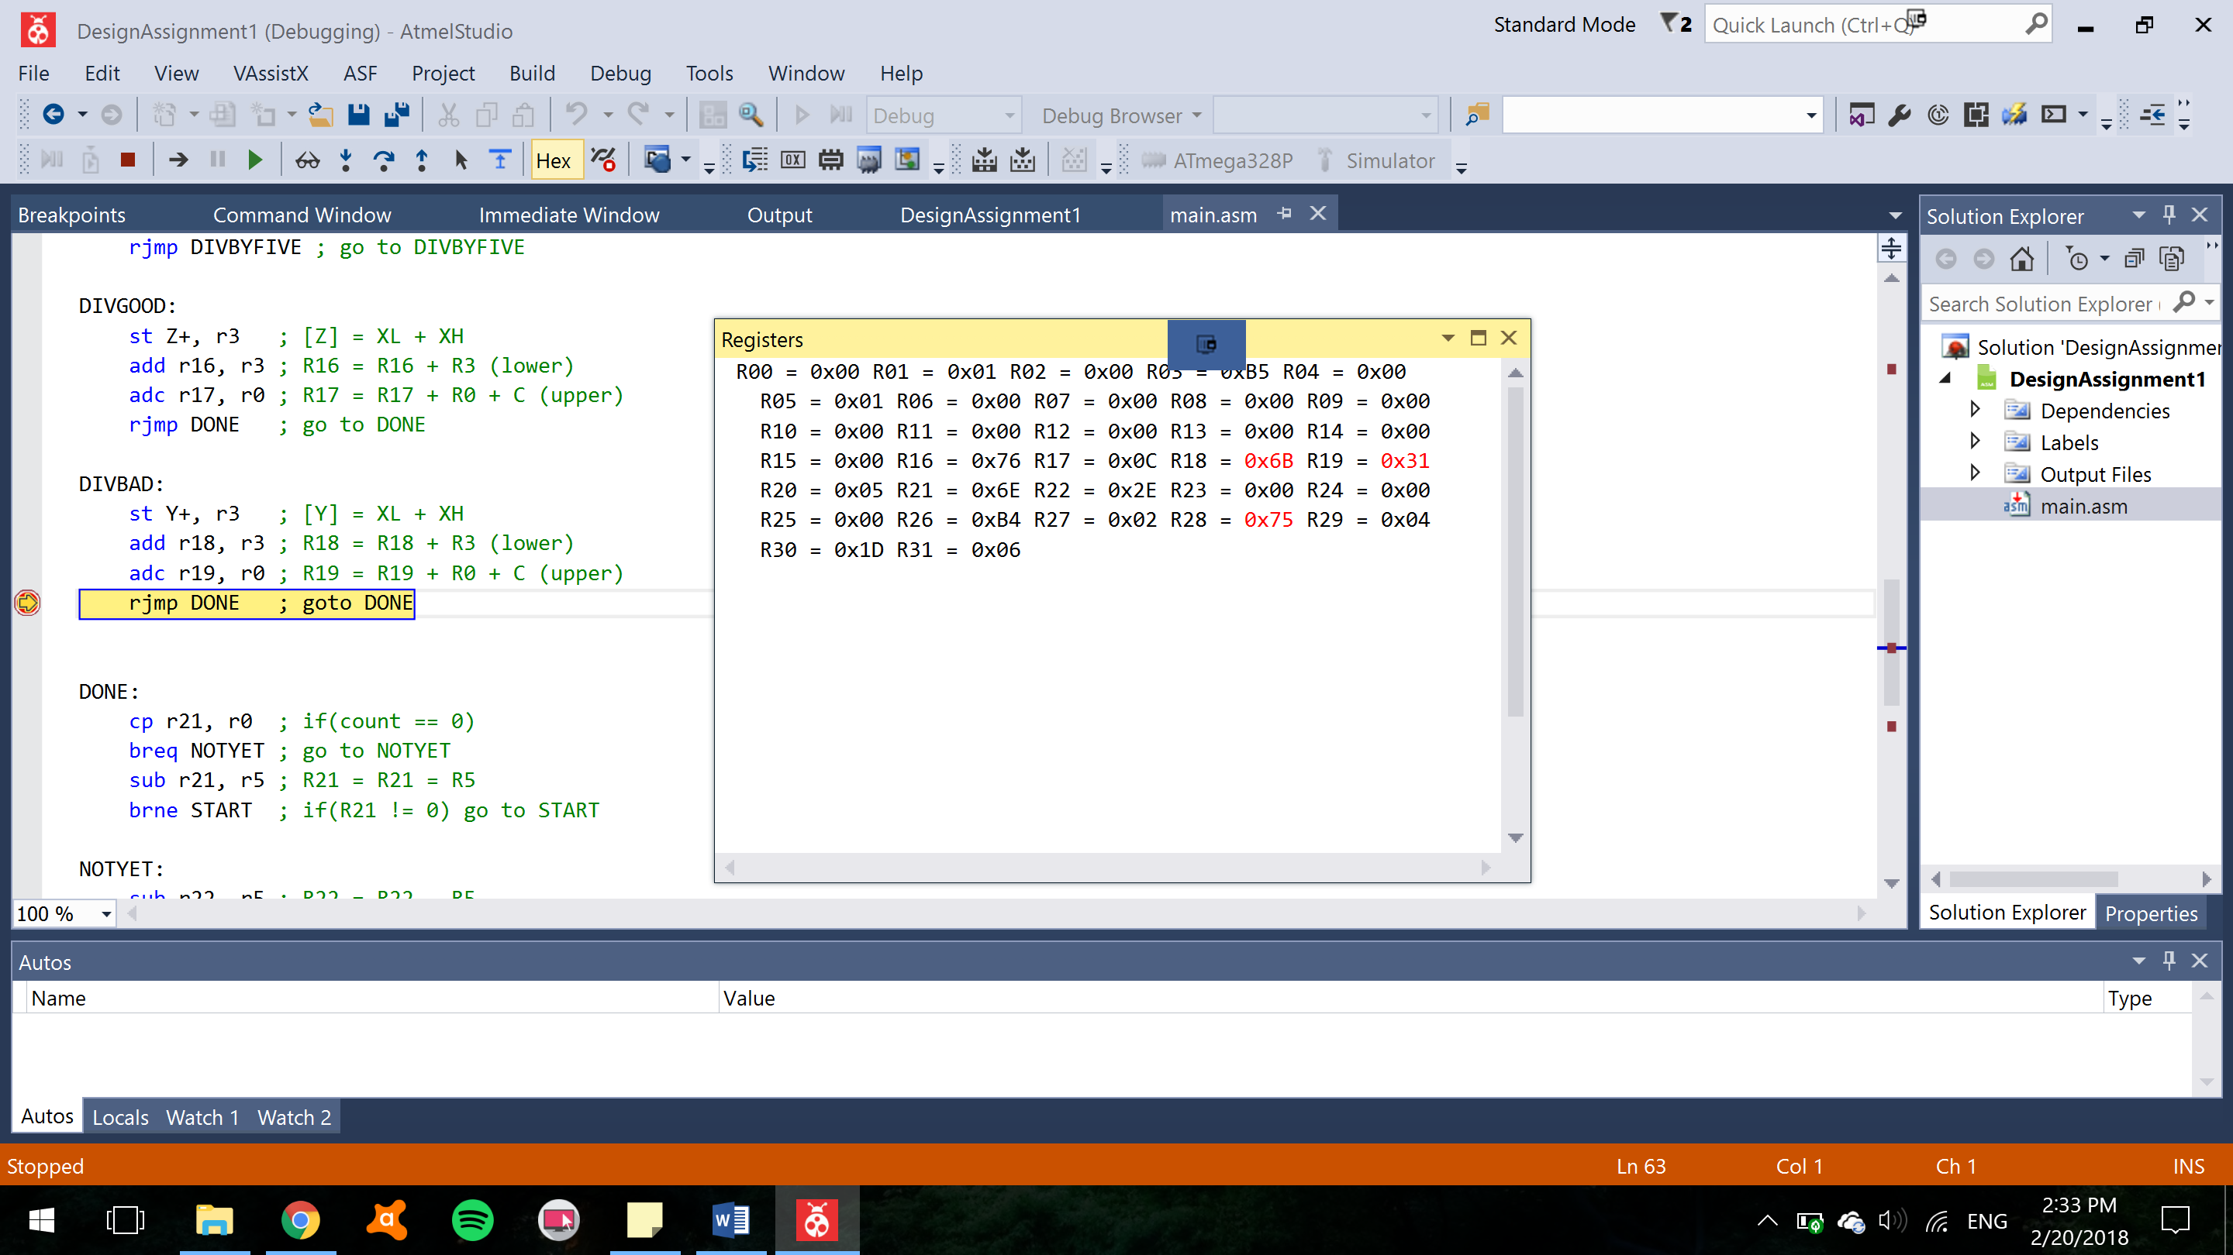

Figure 12 R18:R19 after being added and stored

**TASK 4**

#include <avr/io.h>

int main(void)

{

volatile unsigned int xl = 0;

volatile unsigned int xh = 0;

volatile unsigned int x = 0;

volatile unsigned int y = 0;

volatile unsigned int z = 0;

for(xl=36; xl<=255; xl++) //This loop is for counting from 0x0222 to 0x2FD

{

if(xl % 5 == 0) //if xl is divisible by 5, add to y

{

y = xl + y;

}

if(xl % 5 != 0) //if xl isnt divisible by 5, add to z

{

z = xl + z;

}

}

for(xh=0; xh<=1; xh++) //This loop is for counting from 0x02FE to 0x02FF to account for the overflow

{

if(xh % 5 == 0) //if xh is divisible by 5, add to y

{

y = xh + y;

}

if(xh % 5 != 0) //if xh isnt divisible by 5, add to z

{

z = xh + z;

}

}

for(xh=3; xh<=80; xh++) //This loops is for counting from 0x0300 to 0x034E

{

if(xh % 5 == 0) //if xh is divisible by 5, add to y

{

y = xh + y;

}

if(xh % 5 != 0) //if xh isnt divisible by 5, add to z

{

z = xh + z;

}

}

}

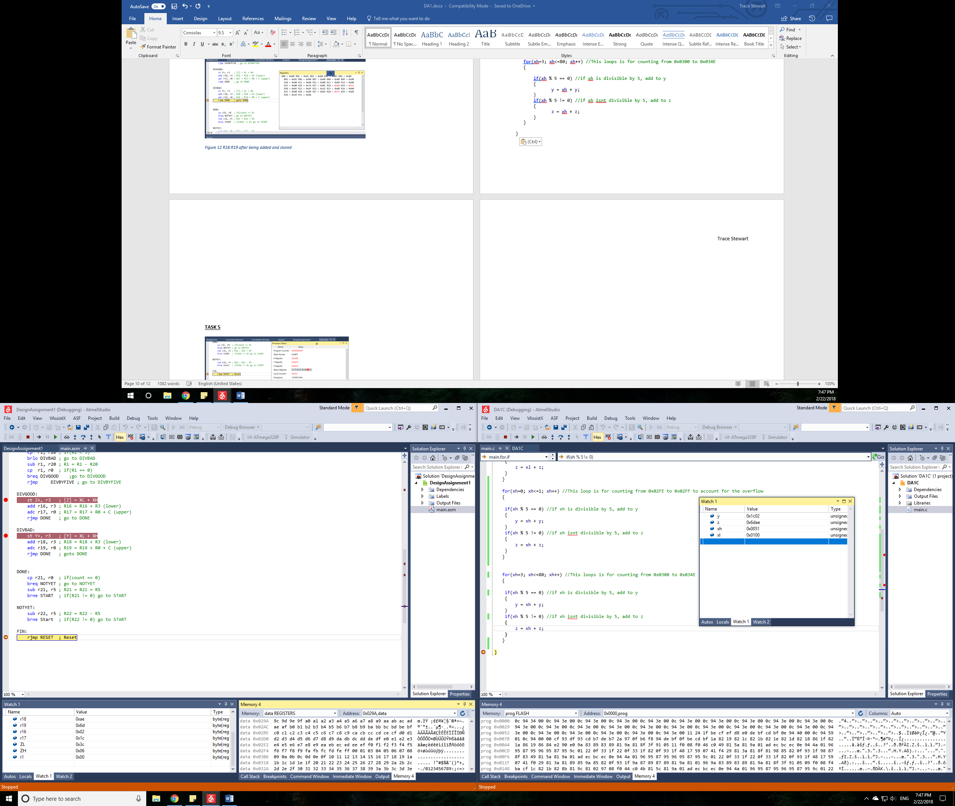

Figure Contents of registers holding the values of Y and Z

After running the code in C, I was able to get the same result as I did with the assembly program.

**TASK 5**

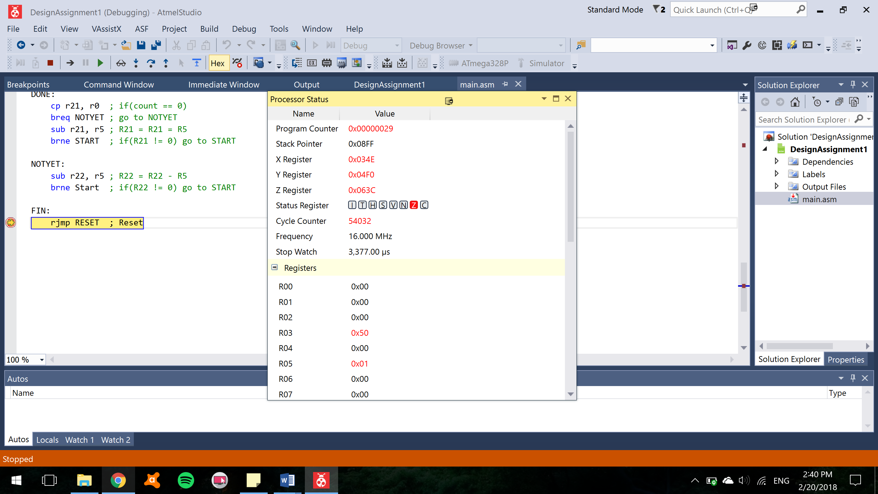

Figure 14 Execution time of 3,360 us at a clock speed of 16 MHz. a Cycle counter of 54,032.

1. **SCREENSHOT OF EACH DEMO (BOARD SETUP)**

None.

1. **VIDEO LINKS OF EACH DEMO**

None

1. **GITHUB LINK OF THIS DA**

https://github.com/TraceStewart/epc103gnirps8102vlnu/tree/master/DesignAssignment1

**Student Academic Misconduct Policy**

<http://studentconduct.unlv.edu/misconduct/policy.html>

“This assignment submission is my own, original work”.

Trace Stewart